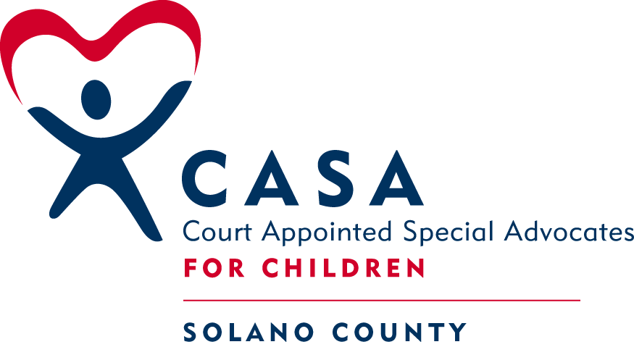
CASA of Solano County
VOLUNTEER APPLICATION

Date:_______________ How did you hear about our program? ______________________________

Personal Information:

Full legal name: _______________________________________________________________________

Other names used: ____________________________________________________________________

Address: ____________________________________ City & zip _____________________________

Date of birth: ___________________________

Phone numbers (include area code): Home:____________________ Work:___________________

Cell/Pager:_____________________ E-mail:_______________________________________________
Languages you speak (other than English): __________________________________________________

Are you a licensed driver? Yes ___ No ___ Do you have a car available for your use? Yes ___ No ___

If you don’t drive, do you have other reliable transportation? ___________________________________

California Driver's License # ____________________ Auto Insurance Carrier:_____________________

Current Occupation:

What is your current employment/occupational status (i.e., employed full-time, part-time, in school, retired, etc)? __________________________________________________________________________________________________________________________________________________________________________

Current or most recent employment: (Job title/ position):_____________________________________

Employer: _____________________________________ City: _______________________________

How long in this position? _________ Major Responsibilities: ________________________________

______
____________________________________________________________________________________

Past Employment/Volunteer History

Please list your work and volunteer activities for the past 10 years below. Use another sheet if necessary.. Check “P” for paid work and “V” for volunteer work experience.
Position/Job Title | Employer/City | Dates | P | V | Reasons for leaving
If you have served as a CASA volunteer or received CASA training in the past, please describe below. Please include the name & phone number of your supervisor or program contact person (if available).

Contact person: _____________________________ Phone number: ___________________________
______________________________________________________________
Educational Background:

High School Name & location: ______________________________ Year of graduation: ___________

_______________________________________________________________________________________________________________
College (Name & location) Diploma/Degree Major/Subjects

_
Additional Degrees, licenses, training

Special Skills/Interests/Hobbies:
____________________________________________________________________________________________________________________________________________________________________________________________________________________________________________________________________________________________________________________________________________________

Emergency Contact:

Name: __________________________________ Relationship to you ____________________________
Phone numbers (with area code):
Screening Information:

A. Have you ever been:
1. Arrested for a crime against a child? Yes ____ No ____
2. Arrested for a violent felony? Yes ____ No ____
3. Arrested for a sex crime? Yes ____ No ____

B. If you have answered “Yes” to any of the above, can you produce a written declaration of a “Finding of Factual Innocence” as described in the California Penal Code, Section 851.8 et. seq. ? Yes____ No ____
Applicants found to have been convicted of or having current charges pending for a felony or misdemeanor involving a sex offense, child abuse, or child neglect must not be accepted as a CASA volunteer.

C. Have you been convicted of any crime within the last 5 years (excluding vehicle code infractions, but including vehicular misdemeanors or felonies)? Yes____ No ____

D. Are you currently undergoing prosecution for any crime (excluding vehicle code infractions, but including vehicular misdemeanors or felonies)? Yes____ No ____

E. Have you ever been arrested or convicted of any crime not mentioned above? Yes ____ No ____

F. Have you ever been the parent, spouse, or partner of a child who has been:

1. The subject of a child abuse/neglect/abandonment report by a child protective
or law enforcement agency? (Y) (N)

2. An adjudicated dependent or ward of any juvenile court? (Y) (N)

3. Placed under informal supervision in any county’s Children’s Social Service agency? (Y) (N)

G. As a child, were you or any siblings ever the subject of a child abuse report? (Y) (N)

H. Are you currently being paid or reimbursed for providing a service to children
or parents within the child welfare or juvenile court system (Y) (N)

I. Have you ever been a foster parent? (Y) (N)

If you have answered “Yes” to any of the above questions, please describe circumstances below. Attach additional sheets as necessary.
__________________________________________________________________________________________________________________________________________________________________________________________________________________________________________________________
Medical Information:

- Are you currently being treated for a condition or taking any medications that might affect your ability to provide services as a CASA advocate or meet the requirements of the CASA program? Yes ____ No ____
If “yes,” please describe briefly.
______________________________________________________________________________________________
K. Within the past 10 years, have you been hospitalized, either voluntarily or involuntarily, owing to a psychiatric condition or mental illness? Yes ____ No ____. If “yes,” please provide details about your hospitalization in the space below or on a separate sheet, including reasons for hospitalization, where it occurred, what precipitated the event, dates of hospitalization, duration of stay, whether single or multiple hospitalizations took place, and how the problem, situation or condition was resolved. (Note: We may ask you to sign a release of information form giving us permission to speak with your therapist, doctor or mental health care provider, and to obtain records from the hospital or treatment program.)
_____________________________________________________________________________________________________________________________________________

L. Within the past 10 years, have you been enrolled in a rehabilitation or treatment program for alcohol abuse, substance abuse or abuse of prescription drugs? Yes ____ No ____. If “yes,” please describe briefly below or on a separate sheet: the type of addiction or substance abuse, duration of time under the influence, type of recovery program managed recovery and current recovery status. (Note: We may ask you to sign a release of information form granting us permission to contact or obtain records from your treatment provider, recovery program and/or sponsor concerning your recovery.)

_____________________________________________________________________________________________________________________________________________

Autobiographical Information:

Please write a brief (1-2 page,) autobiographical statement describing your interest in becoming a CASA volunteer. Use a separate sheet of paper. Please type or print neatly. Address questions & topics below:

- Briefly describe significant events or circumstances in your own childhood, including your family’s strengths and weaknesses. (For example, how did you feel about your parents methods of discipline, communication among family members, relations among siblings? Were family members close and affectionate? Did you receive the support you needed growing up from one or both parents?)

2. What prompted your interest in becoming a Court Appointed Special Advocate at this time?

3. Please describe the special strengths, abilities and/or experiences you’ve had that will help you fulfill the role of CASA advocate?

- Do you have any concerns about how you will cope with emotional distress and challenges of being a CASA to an abused or neglected child?

5. Do you anticipate having any difficulty honoring the time commitment or fulfilling the duties of a CASA advocate? If so, how do you expect to manage the difficulties?

6. How do you hope to benefit from this volunteer experience?

Affirmation and release

I ___________________________________________(print name) hereby affirm that all answers provided on my CASA volunteer applications are true. I hereby authorize the Solano County CASA program, and any law enforcement agency it authorizes, to investigate my background, including a review of DMV records and a check of criminal records, in order to verify my suitability for working with minor children. I understand that the information requested in this application will be used only for the purpose of determining my suitability as a CASA volunteer.

Further, I understand that completion of the CASA training does not guarantee that I will be assigned a case. I understand that I will be expected to serve a minimum of 24 months in the CASA program in order to maintain consistency in protecting the best interest of my assigned child. If unforeseen circumstances prevent me from fulfilling this obligation, I will submit my written resignation to the Program Coordinator with as much advance notice as possible. I am aware of the sensitive and confidential nature of the official documents, reports and other materials I will examine in my capacity as a CASA volunteer. I agree to hold these records and information confidential, in accordance with CASA Program policy. I also understand that I serve “at will” under the auspices of the Solano County CASA Program and the Solano County Juvenile Court and may be removed from a case or the program at any time.

_______________________________________________________ ________________________________
Signature Date

Thank you for your efforts and your candor. This information will help us to know you better and enable us to support your success as a potential CASA volunteer.
Data for Case Matching and Statistical Purposes:

Marital status: Single:___ Married:___ Widowed:___ Divorced:___ Separated:___

Spouse/Partner’s Name: __________________________ Partner’s Occupation:______________________________

Your ethnic background: ___Hispanic ___Caucasian ___Asian (please specify: ___________________________)
___African American ___Native American ___Bi-racial/Multi-racial (please specify:
___________________________________________________________________________)

Name(s) & ages of your own children:__________________________________________________________________

What type of child might you be most comfortable working with?

Male:___ Female:___ Either/both:___ Ages: 0-5 6-12 13-17 any age group

Ethnicity: Hispanic:___ Caucasian:___ Asian:___ Sibling group Yes__ No__
African-American:___ Bi-racial:___ Developmentally Delayed Yes__ No__
Native American:___ No Preference:___ Special Education Yes__ No__
Special Needs Yes__ No__

I could work with a child who has experienced sexual abuse or severe physical abuse. Yes__ No__

Comments: ___________________________________________________________________________________________

Availability

Please indicate below the times you are NOT available for volunteer work or case supervision.

Sun Mon Tue Wed Thurs Fri Sat
Morning
Noon
Evening

Part of your responsibility as a CASA volunteer is to appear in juvenile court on your assigned case(s). Prior to being assigned a case, you will be informed of dates/times that court hearings take place. In Solano County, juvenile court cases are usually heard on weekdays between the hours of 8:30 a.m. and 3:30 p.m. Do you anticipate having any difficulty taking time from work or other commitments to appear in court during these hours when needed (usually not more often than 2-3 times per year)? Yes ___ No ___

Please describe difficulties and what arrangements you can make to be available: _________________________________________________________________________________________________________________________________________________________________________________________________________________________________________________________________________

Guidelines for Choosing your References

Please review before choosing your references:

- We cannot accept references from family members or spouses.

- Please ask people who have known you for 2 years or more.

- References can be friends, neighbors, employers, co-workers, & other people who know your character.

- Reference forms must be mailed, e-Mailed, or faxed directly to our office by the referent.

- We cannot accept reference forms hand-delivered/hand-carried by the applicant.

Our mailing address:

600 Union Avenue, Suite 204
Fairfield, CA 94533

Our FAX number:

707-474-3761

Please contact our CASA Coordinator, for further questions at: coordinator@casasolano.org OR 707-421-2272.

CASA References For

Name of Volunteer: _________________________________________________________________

Please provide us with the names and addresses of three people (non-relatives) who will be able to provide a reference concerning your ability to perform the role of CASA Advocate. People providing references for you may be friends, coworkers, employers, teachers, ministers or other adults who know you well. If relatives or family members wish to provide a reference for you, in addition to your three (non-relative) references, we will happily receive additional recommendations. Letters from family members must be submitted in addition to, not as a substitute for, your three primary references.

Feel free to contact your reference providers in advance to provide information about the CASA program, to explain why you are interested in becoming a volunteer advocate and to describe your role as a CASA Advocate.

Have your reference list prepared prior to the start of training. Our address is provided below:

Attention: CASA of Solano County Phone: 707.421.CASA (2272)
Candy Pierce 600 Union Ave., Ste. 204
Fax: 707.474.3761 Fairfield, CA 94533
cpierce@casasolano.org

1) Name: _________________________________________ Phone: ____________________________________

Street: ______________________________________________ City: _____________________ State:_______

Relationship: ____________________________________________________ Zip Code: __________________

E-Mail: ______________________________________ Alternate Phone: _______________________________

2) Name: _________________________________________ Phone: ____________________________________

Street: ______________________________________________ City: _____________________ State:_______

Relationship: ____________________________________________________ Zip Code: __________________

E-Mail: ______________________________________ Alternate Phone: _______________________________

3) Name: _________________________________________ Phone: ____________________________________

Street: ______________________________________________ City: _____________________ State:_______

Relationship: ____________________________________________________ Zip Code: __________________

E-Mail: ______________________________________ Alternate Phone: _______________________________

